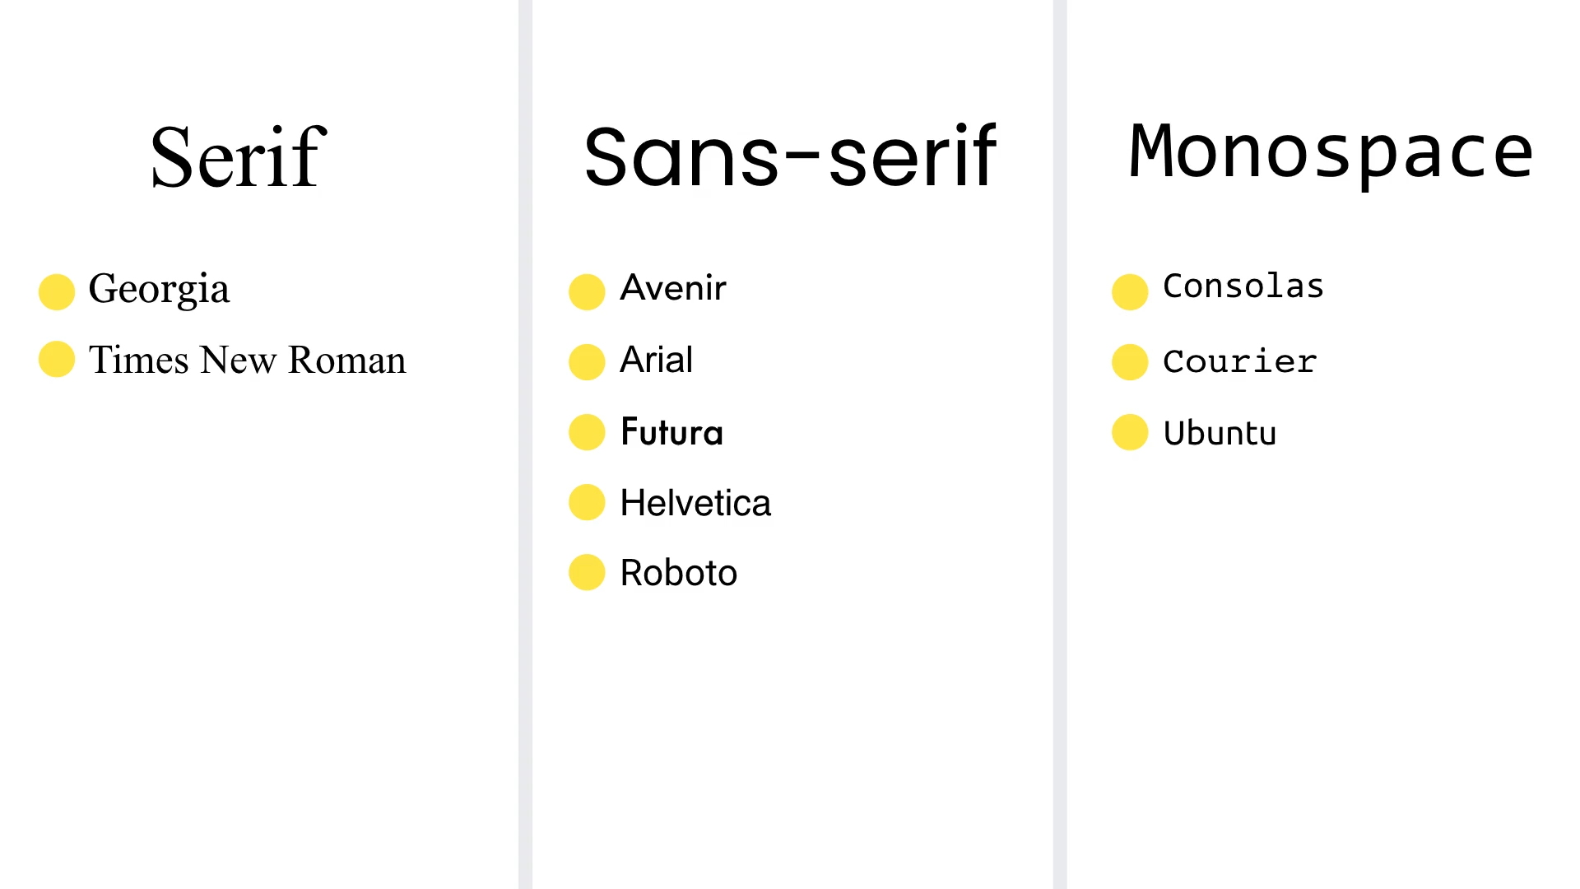

|  |  |
| --- | --- |
| Class | Properties |
| font-sans | font-family: ui-sans-serif, system-ui, -apple-system, BlinkMacSystemFont, "Segoe UI", Roboto, "Helvetica Neue", Arial, "Noto Sans", sans-serif, "Apple Color Emoji", "Segoe UI Emoji", "Segoe UI Symbol", "Noto Color Emoji"; |
| font-serif | font-family: ui-serif, Georgia, Cambria, "Times New Roman", Times, serif; |
| font-mono | font-family: ui-monospace, SFMono-Regular, Menlo, Monaco, Consolas, "Liberation Mono", "Courier New", monospace; |